Stability in sorting algorithms

Stability is mainly important when we have key value pairs with duplicate keys possible (like people names as keys and their details as values). And we wish to sort these objects by keys.

***A sorting algorithm is said to be stable if two objects with equal keys appear in the same order in sorted output as they appear in the input array to be sorted.***

Informally, stability means that equivalent elements retain their relative positions, after sorting.

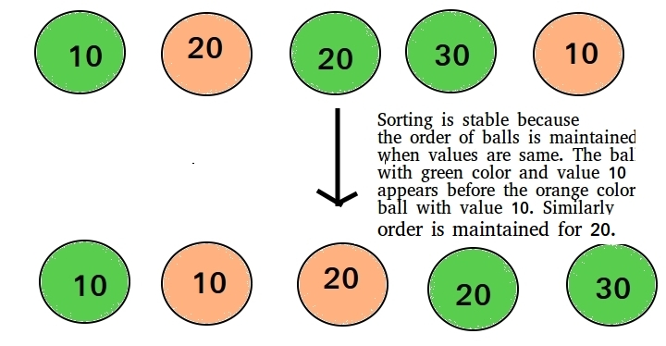

**Which sorting algorithms are stable?**  
Some Sorting Algorithms are stable by nature, such as [Bubble Sort](https://www.geeksforgeeks.org/bubble-sort/), [Insertion Sort](https://www.geeksforgeeks.org/insertion-sort/), [Merge Sort](https://www.geeksforgeeks.org/merge-sort/), [Count Sort](https://www.geeksforgeeks.org/counting-sort/) etc.

**Which sorting algorithms are unstable?**  
[Quick Sort](https://www.geeksforgeeks.org/quick-sort/), [Heap Sort](https://www.geeksforgeeks.org/heap-sort/) etc., can be made stable by also taking the position of the elements into consideration. This change may be done in a way which does not compromise a lot on the performance and takes some extra space, possibly O(n).